**The Poppett and Davies Families in the Staffordshire Conference**

**FAN research includes Pugh, Evans, and Swaine**

**And mini-biographies of Robert Poppett’s guardian families: Cox, Parker, and**

Kristine S Forbes 3 July 2017

**Robert Llewellyn Poppett** (RLP) was born 02 Apr 1806[1] in Worthen Shropshire, England, [to Robert Poppit (1774-1838)](link%20to%20Robert%20Poppit.docx), a widower, and Elizabeth Llewellyn (1774-1836), both of Churchstoke. RLP was baptized 09 Apr 1806 in Churchstoke, Montgomeryshire, Wales.

RLP married **Martha Pugh** (b 1810 in Hope, Shropshire, England) on 10 Jun 1833 at All Saints Church, Worthen, Shropshire, England.[2] He made his mark and Martha signed. Martha was a daughter of **John Pugh** (1761-1841) and **Catherine Davies** (1765-1844). [3]

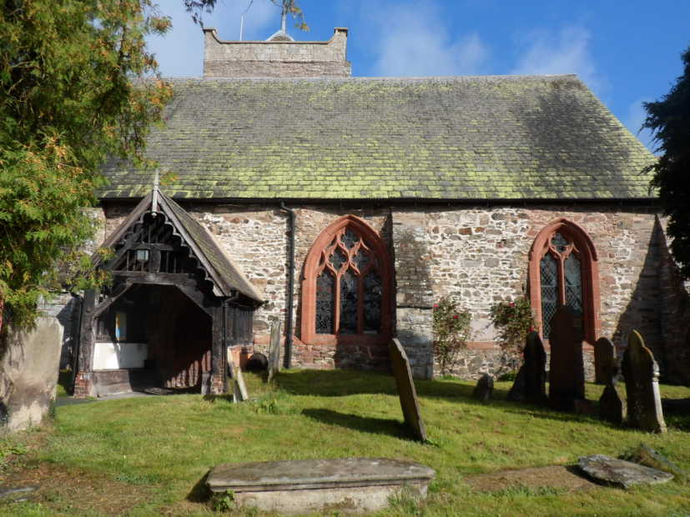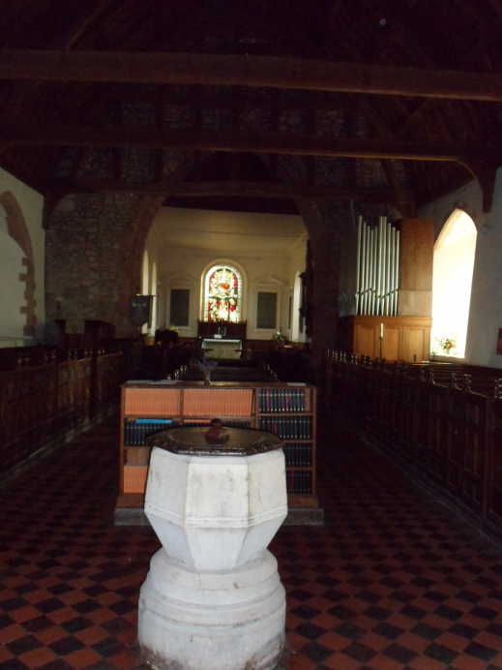

**Robert Albert[4]** (RAP), Robert and Martha’s third child and second son, was born 12 Apr 1839 in Bentlawnt, Shropshire, England[5] and like his siblings, baptized at the All Saints’ Church in Worthen. Information about his siblings can be found [here](Link%20to%20Family%20of%20Robert%20Llewellyn%20Poppett%20and%20Martha%20Pugh.docx).

Wife Martha died 25 Mar 1844[6]; baby Jane died 5 Jun 1844[7], both in Bentlawnt. Per Martha’s death certificate, Robert was a shoemaker at this time.[8]

**RLP SECOND MARRIAGE AND MORMON CONVERSION**

RLP married again 15 Feb 1847, a spinster named Emma Picking (b 1817), daughter of Thomas.[9] They married in the Church of England. Both signed with a mark. Witnesses were **William Edwards** **and Sarah Collins**.

Six months later, RLP and Emma were baptized into the LDS church in Shrewsbury, Shropshire, England.[10] RLP was baptized 29 Aug 1847 by [John Evans](link%20to%20John%20Evans.docx) (at the Staffordshire conference?). A Robert Poppett was also baptized the following year (again at the Staffordshire conference?) by John Evans, this time confirmed by a T. Thomas.[11] It is possible this latter incident was for the son.

Four months later, on 30 Dec 1848, RLP sent his second son, RAP, to live with the Saints. About a dozen Saints traveled on the Lord Sandon, which carried 222 passengers.[12] As published:

“His father had become a convert of Mormonism and desired to come to America, but not being financially able to provide passage for all his family, placed the child in the care of a friend. The party landed at New Orleans and sailed up the river to Council Bluffs. Here the man who had Robert in charge died and the boy was left with strangers. He was taken to Utah in 1849 and, although but ten years old, helped with the herding of cattle and guarding the stock. He lived with twelve different families before he reached the age of eighteen years.”[13]

To whom did RLP entrust his son? Young Robert’s name can be found on the ship’s passenger list next to a [**Thomas Davis**](Link%20to%20Catherine%20Davies.docx) **(Davies?)**, age 33, and near a [**John Evans**](link%20to%20John%20Evans.docx) who had a wife named **Harriett**, each of which is a likely candidate. We will recall that the priest who baptized RLP the first time in Shropshire in 1847 and then again in 1848 was a **John Evans**. Many John Evans’ eventually made the trek to Utah from Council Bluffs, but none that I can find with a Harriett. Perhaps it was she who died? Neither have I been able to place this Thomas Davies within a Shropshire family as of yet; nor can I find evidence of a likely candidate within the Overland Pioneer database, although if he died, that is not surprising, nor do they appear in any other document connected with Robert that I can find.

**ROBERT POPPETT AMONG THE SAINTS IN AMERICA**

We next find Robert in the 1850 census in Pottawattamie, Iowa, the staging area for the Mormons who were preparing to travel overland to Utah. Robert, age 11, was living with [**John Cox**](Link%20to%20John%20Cox.docx) **and his family: wife Eliza**, daughters Elizabeth, Mary and Sarah[14].

The next year, still in Pottawattamie, young Robert is living with [**William H. and Mary Ann Child Parker**](Link%20to%20William%20H%20Parker.docx) and their children. [15]

RLP was excommunicated 23 Mar 1856 at the Asterley, Shropshire, England. He was cut off for neglect of duty. [16] News of polygamy and other new doctrine reached Britain in 1853, which historians believe caused a spike in “apostasy” [17]which could have been RLP’s motivation.

*No further mention of wife Emma. Did she die?*

**FOUNDING A NEW MORMON COLONY IN SOUTHERN CALIFORNIA**

Returnees from the Mormon Battalion convinced Brigham Young to start a colony in southern California that could be a waystation for Saints arriving in the US in San Pedro. The original colonists left Salt Lake for San Bernardino in 1851, and in subsequent years many more families left Utah for San Bernardino.

RAP arrived at age 15 in 1854.[18] Brigham Young recalled the faithful in California back to Utah in preparation for the Utah War late in 1857.[19] RAP was among the original LDS pioneers who remained in San Bernardino.

In 1860[20], 21-year-old Robert, described as 5'9" tall and weighing abt 160 lbs,  was a farmer and living with fellow LDS **pioneers Alvah Calvin and Elizabeth Haws Downey**, who had married in Pottawattamie in 1849. [21]

RAP married **Alice Addelaide Case**, the 14-year-old daughter of a fellow LDS pioneer **Gashum Caleb Case** in San Bernardino in 1863 by a judge in her home.[22] Per DixieDiane_Miller: Many of those that remained had civic ceremonies by a Judge in their private homes.” Robert and Alice’s first child was born in San Bernardino in 1864.[23]

**BACK IN SHROPSHIRE**

In 1861, on 5 Oct, RLP married spinster **Mary** [**Swain**](Link%20to%20Swain%20family.docx) (born 1834) at the registry office in Montgomeryshire, Wales. [24] (This Mary Swaine was a cousin once removed from the Mary Swaine who was living next door to RLP and his son in 1851). The document indicates RLP was a shoemaker at this time.

In 1868 RLP was baptized again into the LDS church, on 14 May 1868, by [**Edward Davies**](Link%20to%20Catherine%20Davies.docx).[25] His wife Mary Swain was baptized LDS the same day. One week later, on 21 May 1868, RLP and wife Mary were confirmed in the church in Asterley by **William Bain**. In June RLP was ordained a priest by **N.B. Baldwin, Jr. and Thomas James** in Staffordshire.

RLP placed a notice in the 11 Jan 1870 edition of the Millennial Star in hopes of locating the son he had sent to Zion.[26]

*INFORMATION WANTED of the whereabouts of Robert Poppet, who emigrated to Council Bluffs in 1848, and afterwards to Utah. –Address Robert Poppet, sen., care of* [*Edwin Davis*](Link%20to%20Catherine%20Davies.docx)*, Big Engines, Asterley, near Minsterly, Shropshire, England.*

In 1871 RLP is again a lead miner, and was living at 82 Hope Common, Worthen, Montgomeryshire, Wales, with wife Mary and a boarder, [**Samuel Davies**](Link%20to%20Catherine%20Davies.docx), age 4.

**BACK IN SAN BERNARDINO**

Robert Albert Poppett was 31 years old and a teamster operating a 12-mule team in San Bernardino in 1870. He and his wife and 3 sons lived in the family home he had built in the original colony in San Bernardino. RAP had become a naturalized citizen in 1867, at which time he was still a farmer.

RAP must have heard of the notice in the Millennial Star within a few years of its being published.

“Twenty-eight years after leaving England, Mr. Poppett received the first news of his father through an advertisement in a Salt Lake paper. Shortly after, he brought his father to California where he made his home with Robert.”[27]

RLP departed from Liverpool on 13 Jun 1877 on the Wyoming, arriving in NYC 23 Jun 1877[28]. The Salt Lake Herald on 30 Jun 1877 listed him among those expected in Utah shortly[29]; also in the group were **Edward, Sarah, Albert, Sarah Ann and Alfred** [**Davies**](Link%20to%20Catherine%20Davies.docx). This is likely the **William Davies** who baptized him in Shropshire so many years ago, and also the father of Edwin.

**The Robert Poppetts in San Bernardino**

By the time RLP came to live with his son in San Bernardino, RAP had purchased a number of additional properties, and built a large new family home. He had 2 more sons. He was a member of the Masons[30]. He had invested in various mining claims.

In 1880 RLP was in the home of son RAP had built on his 27-acre property in San Bernardino. A set of boy/girl twins had been added to the family. (*The girl, Irene, was my great-grandmother, the first of our line to be born in San Bernardino. I would be the fourth.*)

1881, RAP’s nephew Herbert Poppett, son of RAP’s brother John, emigrated to San Bernardino at age 17.[31] In England, Herbert had had little opportunity to attend school. At 12 he began making his own living; while working out in service in England his compensation consisted of board, clothes and $30/year.[32] 1881 census in Shropshire he was an unemployed page.[33] Herbert arrived in NYC 29 Apr on the Republic. [34]His first employment in SB was with a threshing machine[35].

1887 RAP purchased a homestead he would call Poppett Flats, where eventually his son Ed would run a dairy. He put Herbert to work there: Herbert repaired and was living in an old adobe building that was a vaquero shelter[36]. Herbert also helped his cousin Ed build a home there. Ed married the daughter of original LDS pioneers Silas and Chloe Dodson Cox Nov 1888 and took his new bride to live in this house. Herbert thrived; by age 27, Herbert was able to buy property and plant an orange grove, a business he would run the rest of his life.

For thirty years [Robert Poppett} worked on the desert, driving team and freighting with a twelve-mule team from San Bernardino to distant points. He purchased a large ranch in San Bernardino and also one in San Jacinto valley.[37][38]

1894 a creek and canyon near his homestead in San Jacinto are named for Robert Poppett.[39]

RLP IN SAN BERNARDINO

* In 1884 RLP is baptized into the RLDS in San Bernardino.[40]
* 1892 RLP dies in San Bernardino. Buried at Pioneer Cemetery.[41]

RAP’s wife died in 1902. Buried at Pioneer Cemetery.[42]

1903 RAP and eldest son, John, travel to England to visit his brother [John](Link%20to%20Family%20of%20John%20Poppett%20and%20Martha%20Hincks%20in%20Shropshire.docx) in Shropshire.[43] Most if not all of John and his wife Martha’s children (other than Herbert) were still living nearby. Robert’s sister Ann Poppett Hitchen had passed away but her husband Edmond was living; sister Elizabeth had moved to Canada.

In 1914 (age 75) he traveled to Canada to visit his sister [Elizabeth Swain](Link%20to%20Family%20of%20Elizabeth%20Poppett%20Francis%20Swain.docx). [44]

He wrote a letter home to his son: “I wrote you a few lines to let you know I mad the trip in fine shape. found sister  ? well & Geo Swain and sister are about the same age about 76 or 77…” [45]

RAP died in 1918. Buried at Pioneer Cemetery.[46]

1. Baptism certificate in his profile
2. Copy of marriage certificate attached to RLP profile
3. From chris099: I have found Martha Pugh's brothers & sisters; I am at the moment looking for Catherine Davies sisters & brothers but I can only find a sister Mary born in 1762. I have also found a death for Martha parents John & Catherine which I am going to add. Just added MC for John & Catherine Pugh , Martha's parent's, also found Martha's brother William's baptism in Chirbury, I will try and find the other baptisms.”
4. Robert gave a middle name “Albert” on his naturalization documents: U.S. Naturalization Record Indexes, 1791-1992 NARA Washington, D.C.; Index to Naturalization Records of the U.S. District for the Southern District of California, Central Division (Los Angeles), 1887-1937 (M1607); Microfilm Serial: M1607; Microfilm Roll:
5. RAP’s birth certificate and baptism register notes in his profile
6. Death certificate and burial register in her profile
7. Death certificate and burial register in her profile
8. Chris099: “I went over to Worthen a couple of months ago to look for Gravestones but I could not find any.” 
9. MC in his profile
10. LDS records found and photographed from microfilm at Family History Center in Seattle. Peter Skellon: On subject of LDS many of my ancestors are involved with LDS or Primitive Methodism, maybe as a result of harsh life.
11. Film #0086976
12. Lord Sandon passenger list found on Mormon Migration website; copy of handwritten passenger list in his profile.
13. Our Pioneer Heritage Volume 4 The Mormons in San Bernardino Part Ii Freighting—Utah—San Bernardino A Tribute
14. census
15. census
16. LDS records on microfilm
17.
18. In 1854 Mr.Poppett came to San Bernardino County where he established a permanent home. Per Pat Hughes on ancestry: concerning the Lyman and rich wagon Company that Robert Poppitt, Gashum Case and Bushrod Washington Wilson were on—and several other members of the family that they married into.”
19.
20. census
21.
22. Copy of marriage record in San Bernardino archives, from Book A page 41 (a newspaper article mentioned the location of the marriage. Covered Wagon Series? Need to locate.)
23.
24. From pskellen 2May2017: Shoemaker or cordwainer is often what unemployed men do to make ends meet in those times.  
    
25. LDS microfilm
26. Millennial Star, 11 Jan 1870, page 32.
27. References per DixieDianeMiller: The Odyssey was published by the San Bernardino Historical Society. Our Pioneer Heritage book I believe is a Mormon published book.  
    ODYSSEY, Oct 1986, page 55-57   
    SAN JACINTO VALLEY,   
    OUR PIONEER HERITAGE, THE MORMONS IN SAN BERNARDINO, VOL 4, 1961, page 435 
28.
29.
30. Poppett Lodge papers in my private collection.
31.
32. Source: John Brown, History of SB and R Counties, 1922, Vol III.
33.
34.
35. per Brown, 1922
36. Quimby book
37.
38. <http://www.sbhistoricalsociety.com/storage/Odyssey%20V.%2080055.pdf> The Poppett Family
39. Gunther: **Riverside County, California, Place Names: Their Origins and Their Stories: Poppet Creek; Poppet Flat, 1984, page 400; also “Back in the Day: Poppet Flat bears Engluishman’s name.”** 
40.
41.
42.
43. San Bernardino County Sun, 2 Apr 1903, page 5: “Robert Poppett and son, John Poppett, are planning to leave for England, where they will pay an extended visit [to] the elder Poppett’s former home, where they will be the guest of relatives.”
44.
45. Family collection
46.